🔋 Electric Vehicle Data Analysis Project

This project involves a comprehensive analysis of electric vehicle (EV) data using Python. The dataset includes various technical and performance specifications such as price, range, battery capacity, energy consumption, and more. The goal is to derive meaningful insights, visualize key relationships, detect outliers, and build a simple EV recommendation system. Statistical methods are also used to compare performance between leading EV manufacturers.

📊 Project Objectives:
- Filter and group EVs based on customer criteria (e.g., price and range).
- Analyze and compare EV specifications across different manufacturers.
- Detect outliers in energy consumption using statistical methods.
- Visualize the relationship between battery capacity and range.
- Build a recommendation class to suggest EVs based on user preferences.
- Perform hypothesis testing to compare engine power between brands (Tesla vs Audi).
- Provide actionable insights based on data exploration and statistical analysis.

🧰 Tools & Libraries Used:
- Python
- Pandas – data manipulation
- NumPy – numerical operations
- Matplotlib / Seaborn – data visualization
- Jupyter Notebook – for coding and documentation

📂 Project Structure:
- EV_Data_Analysis.ipynb – Main Jupyter Notebook with code, analysis, and visualizations.
- FEV-data-Excel.xlsx – Dataset used for analysis.
- README.md – Project overview and instructions.

🧪 Key Features:
- Interactive Filtering: Identify EVs under a given budget and with a desired range.
- Statistical Analysis: Outlier detection and t-tests for hypothesis evaluation.
- Recommendation Engine: Custom class to recommend top 3 EVs based on user input.
- Clear Visualizations: Plots and charts to support insights and findings.
- Data Storytelling: Narratives accompanying each task to explain the outcomes.

🎯 Outcome:
The analysis provides useful insights for customers, manufacturers, and stakeholders in the EV market. By exploring real-world vehicle specs, the project demonstrates how data-driven decisions can be made for EV selection and comparison.
Graph:
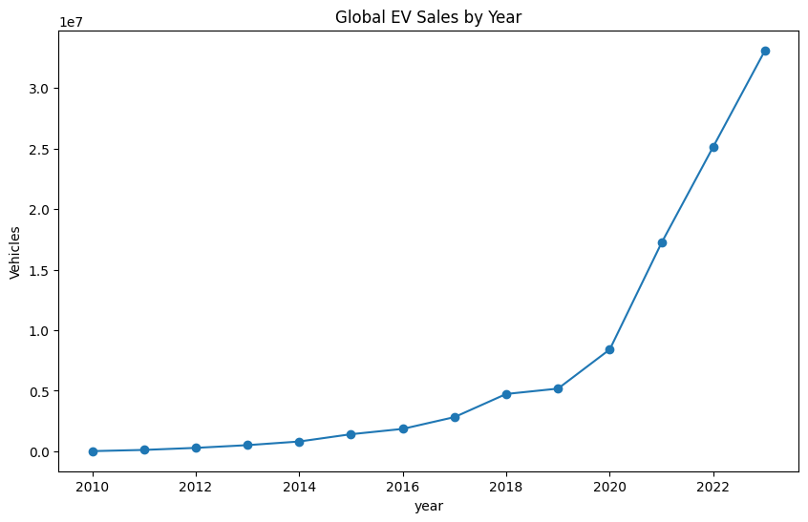
Line graph titled Global EV Sales by Year shows the growth in electric vehicle sales worldwide from 2010 to 2023. It highlights a steady rise in adoption, with a sharp surge after 2020, crossing 30 million units by 2023. Such a plot is valuable in data analysis projects because it clearly illustrates long-term trends, helps identify inflection points in market growth, and supports forecasting future adoption patterns in a visually intuitive way.

Stacked area chart titled EV Stock Growth by Powertrain shows how electric vehicle adoption has evolved from 2010 to 2023, broken down into BEVs, PHEVs, and FCEVs. It highlights BEVs as the dominant contributor, with PHEVs adding moderate growth and FCEVs remaining minimal. Such a plot is useful in data analysis projects because it allows clear visualization of category-wise contributions, helps compare technology adoption trends, and supports insights into market dynamics over time.
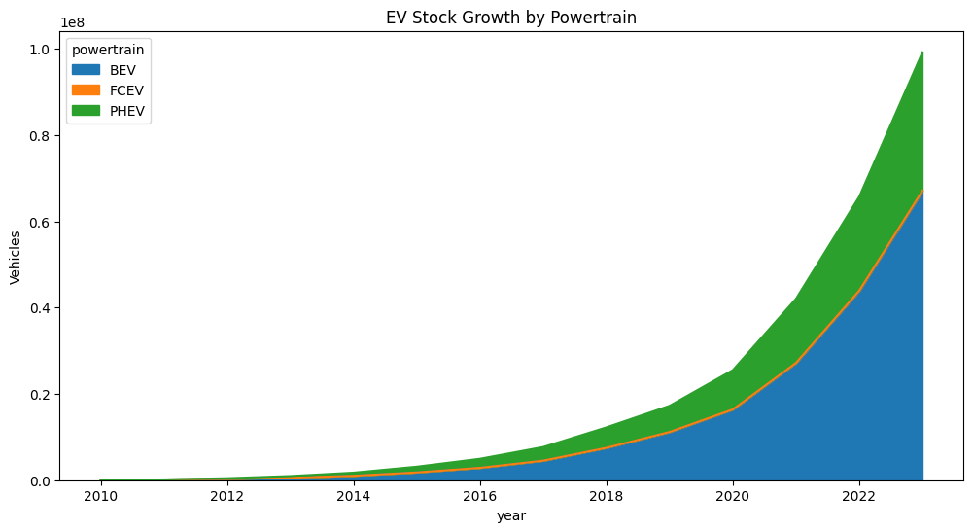

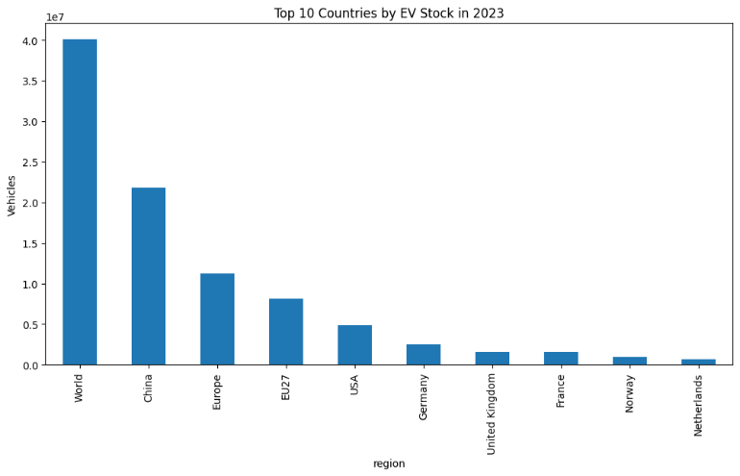
Bar chart titled Top 10 Countries by EV Stock in 2023 compares the number of electric vehicles across major regions and nations. It shows China and Europe leading the adoption, with the USA and individual European countries following at lower levels. Such a chart is useful in data analysis projects because it highlights regional disparities, identifies market leaders, and provides a clear comparative view of global EV distribution, making it easier to analyze adoption patterns and policy impacts.

Line graph titled BEV vs PHEV Sales Over Time compares the adoption trends of battery electric vehicles and plug-in hybrids from 2010 to 2023. It shows BEVs accelerating sharply after 2019, surpassing 22 million units by 2023, while PHEVs grow more steadily, reaching just over 10 million. Such a visualization is valuable in data analysis projects because it highlights comparative growth patterns, helps identify market preferences, and supports forecasting by showing which technology is gaining dominance over time.

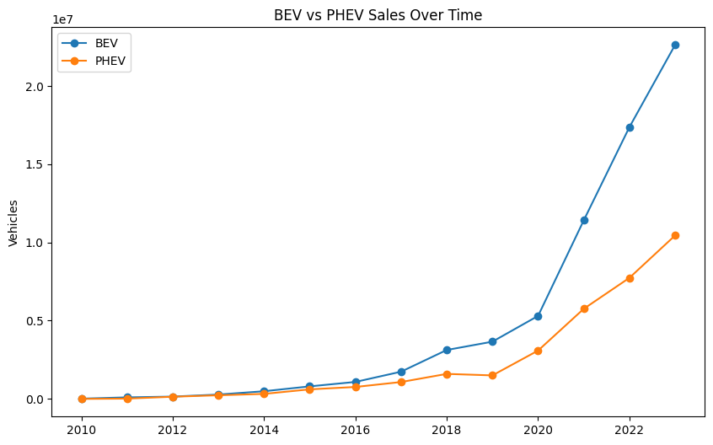

This pie chart titled EV Sales Distribution by Powertrain shows the market share of BEVs, PHEVs, and FCEVs. BEVs dominate with over two-thirds of total sales, PHEVs hold a substantial share, and FCEVs remain negligible. Such a chart is useful in data analysis projects because it provides a clear snapshot of category proportions, helps identify dominant technologies, and supports strategic insights into consumer preferences and market direction.
